**Access private instance from public**

Create new vpc and give cidr range as followed in picture.

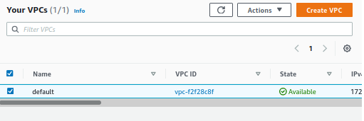

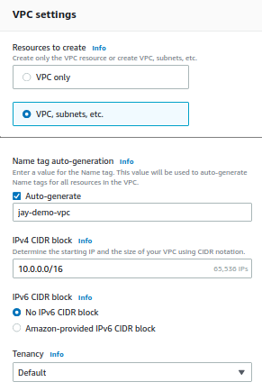

Select 1 availability zone a nd public and private subnet numbers.

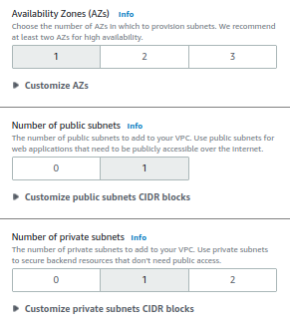

Enable DNS hostname.

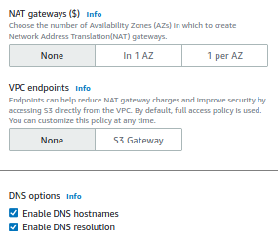

Verify vpc details from side diagram.

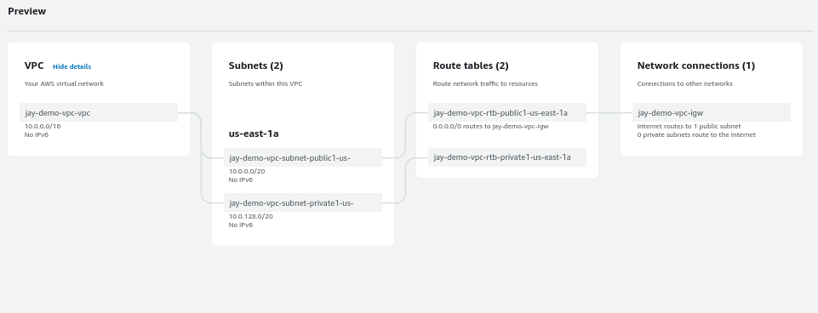

Verify all component creation details.

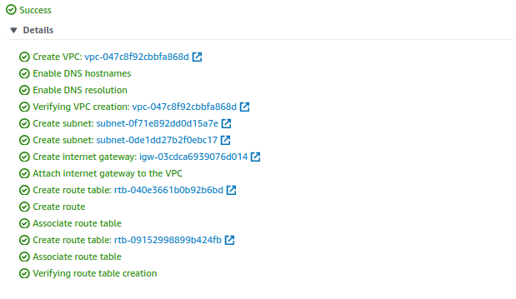

Verify created subnet and route table and route table entry by vpc automatically.

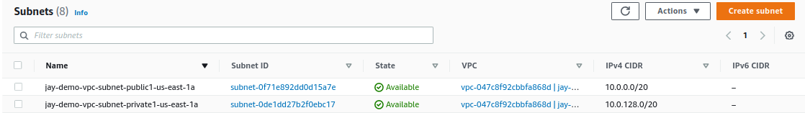

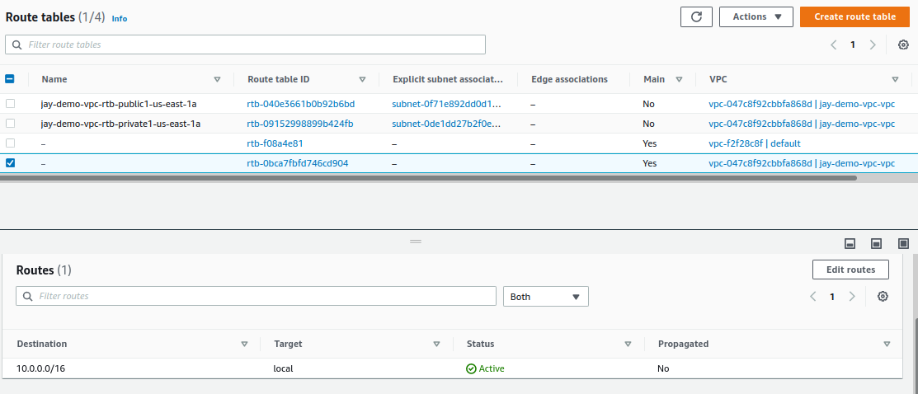

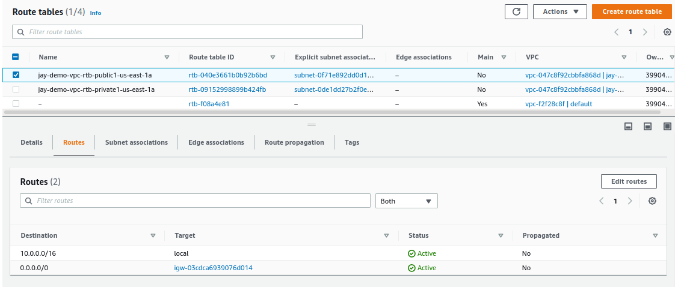

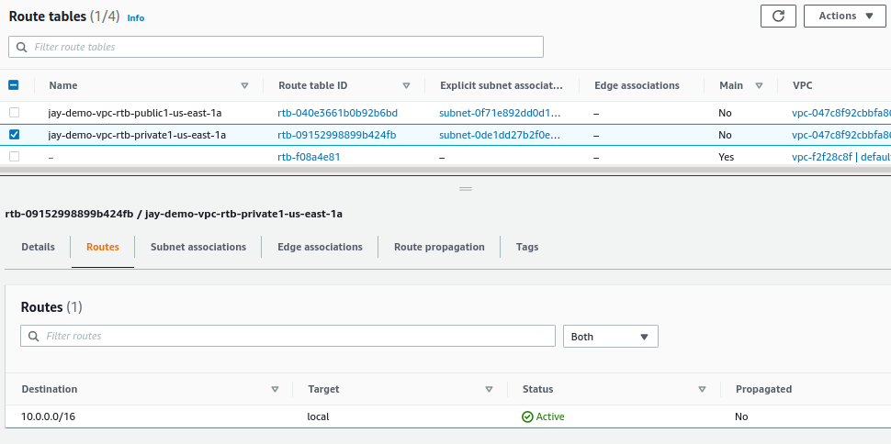

Configure 2 ec2 instance one in private subnet and one in public subnet.

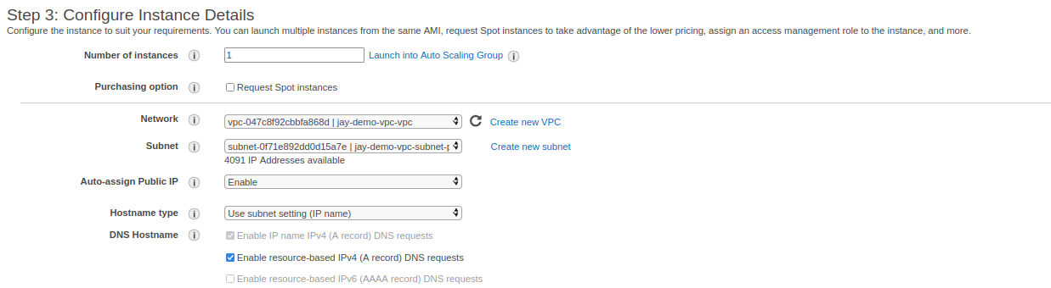

Sequrity group of public instance allowed only of ssh from outside world.

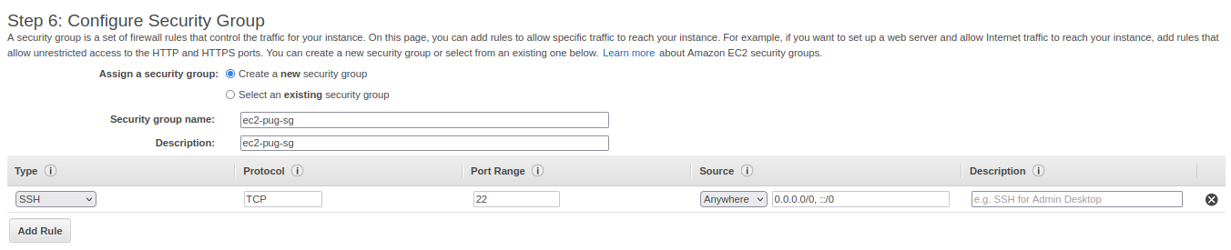

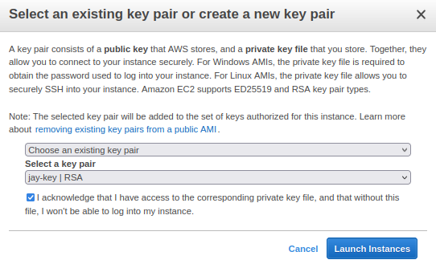

Configure 2nd instance in private subnet.

Do not forget to enable auto assing ip enable.

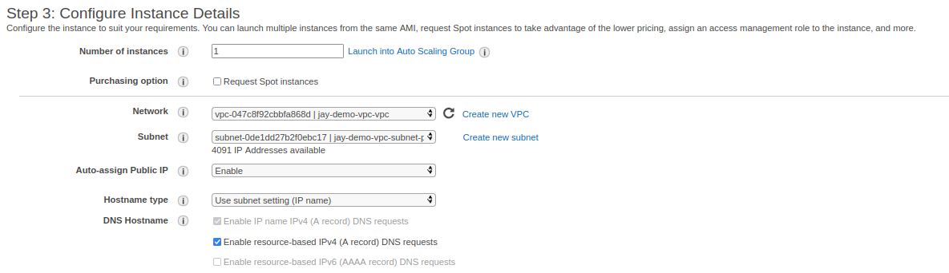

Sequrity group of private instance only allowed icmp and ssh traffic only from public instance.

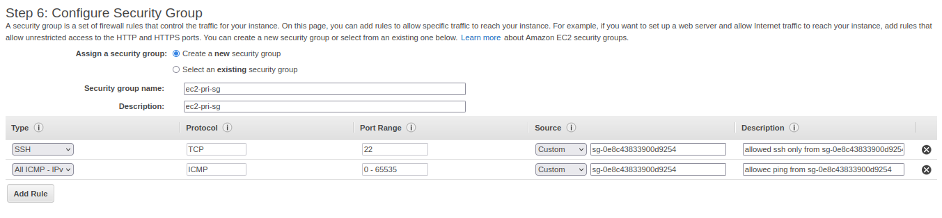

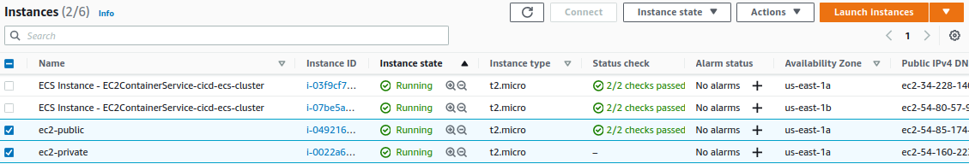

Verify public and private instance details.

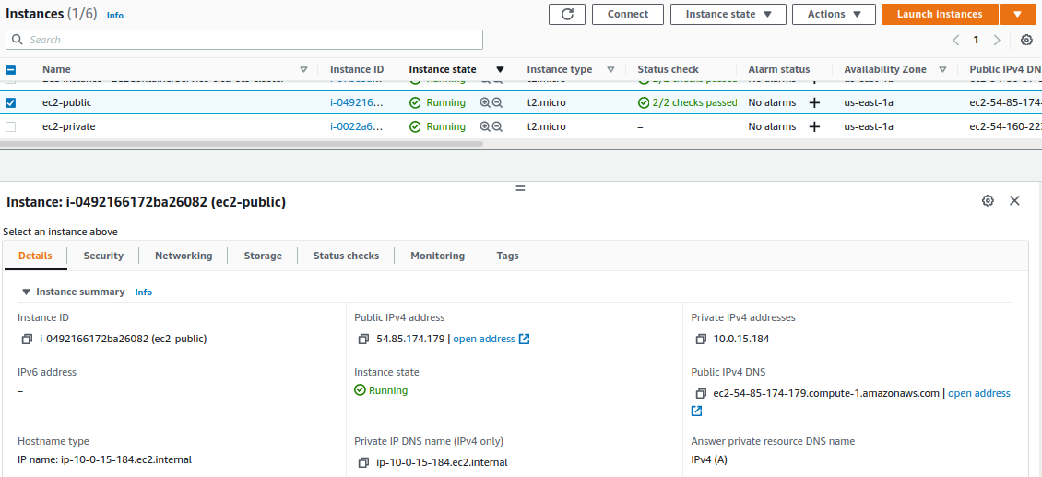

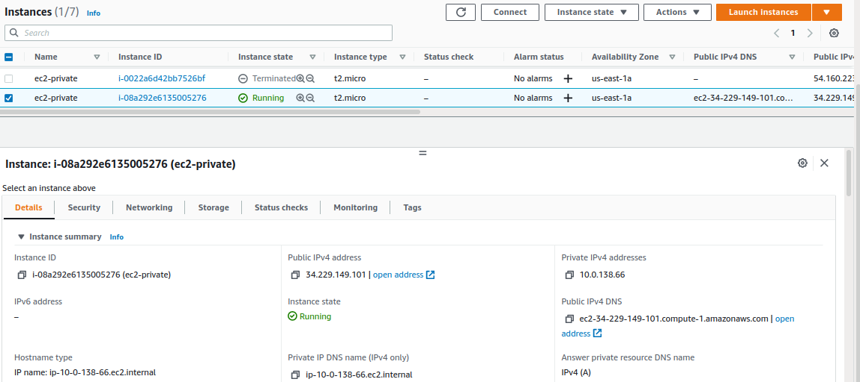

Now take ssh from your laptop to public instance and verify internet connectivity by ping to google.com.

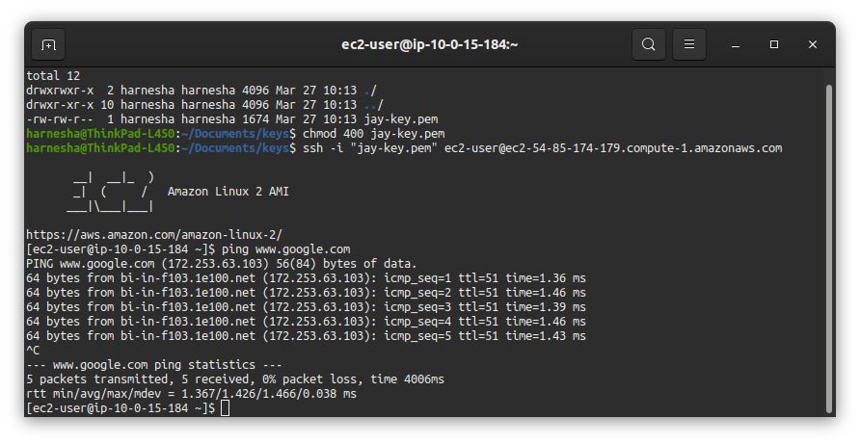

We can see that we can ping private instance from its private ip only its public ip cant be accessed by public instance also.

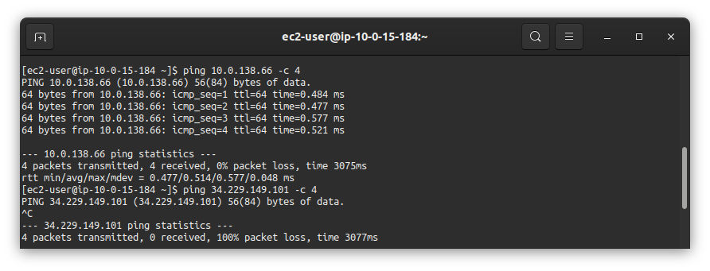

Now upload private key for connecting private instance from public instance.

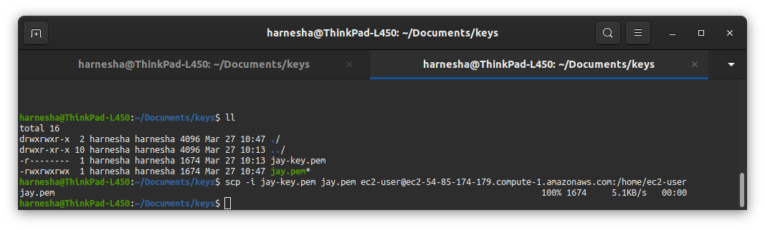

Verify uploaded private key from computer in public instance.

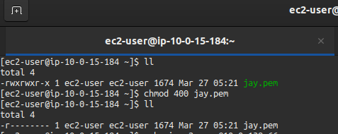

Now take ssh from public instance and we can see that this is only allowed from private instances private ip.

